Task 4

Speed, SEO, and Conversion Audit
Homepage audited: https://accounting-firm-website-one.vercel.app/
Report date shown in screenshots: July 9, 2026, 12:36:09 AM
Final outcome  The homepage exceeded the required mobile performance score of 85. Mobile performance reached 98 and desktop performance reached 100. | SEO outcome  The Lighthouse SEO audit returned a score of 100 on both mobile and desktop, passing the core on-page SEO checks.

Tools used
- Google PageSpeed Insights for performance, accessibility, best practices, and SEO results.
- Lighthouse SEO audit within PageSpeed Insights for core on-page SEO checks.
- Manual conversion review against the client brief and the homepage call-to-action path.

Final PageSpeed Insights results
Device | Performance | Accessibility | Best Practices | SEO
Mobile | 98 | 95 | 100 | 100
Desktop | 100 | 95 | 100 | 100
Note: The screenshots show no field data available, so the results are lab-based PageSpeed/Lighthouse results.

Changes made and why
Change | Reason
Image optimization | Large images were resized and served more efficiently to reduce page weight and improve mobile loading.
Responsive image delivery | Next.js image sizing was used so browsers could request more appropriate image sizes instead of oversized assets.
SEO metadata | The homepage title, meta description, Open Graph metadata, and metadata base were set to make the page clearer for search engines and previews.
Sitemap and robots files | Sitemap and robots files were added so search engines can understand which pages should be crawled.
Responsive layout review | The hero, navigation, card grids, CTA areas, and text sizes were checked for mobile readability and tap-friendly interaction.
Conversion alignment | The page keeps one primary action: Book a free consultation. It avoids pricing tables, cheap-accounting language, fake testimonials, and unnecessary claims.

Core on-page SEO checks
Check | Status | Notes
Clear page title | Passed | The page title identifies the business type and target audience.
Relevant meta description | Passed | The description explains the service and references London sole traders, freelancers, consultants, and small limited companies.
Single clear H1 | Passed | The homepage uses a clear primary heading aligned with the client brief.
Semantic structure | Passed | Content is organized into readable sections for services, personal support, resources, and contact action.
Crawl support | Passed | Sitemap and robots files support search engine discovery.
Mobile-friendly content | Passed | The layout stacks cleanly and keeps the call to action visible on mobile.

Conversion audit
Area reviewed | Finding
Audience clarity | The homepage immediately tells visitors it is for sole traders, freelancers, consultants, and small limited companies.
Primary CTA | The primary CTA remains Book a free consultation, matching the brief and avoiding quote-led positioning.
Trust positioning | The copy emphasizes reliability, responsiveness, and personal support from a small team.
No distracting proof claims | The page avoids fake testimonials, fake client logos, pricing tables, and exaggerated credentials.
Mobile conversion path | The mobile layout keeps text readable and the consultation CTA easy to reach.

Conclusion
The homepage passes Task 4. The final mobile performance score is 98, which exceeds the required score of 85. Desktop performance is 100. The Lighthouse SEO audit score is 100 on both mobile and desktop. The page also remains aligned with the client brief by focusing on reliability, responsiveness, personal service, and the Book a free consultation CTA.

Screenshot evidence

Mobile PageSpeed Insights result
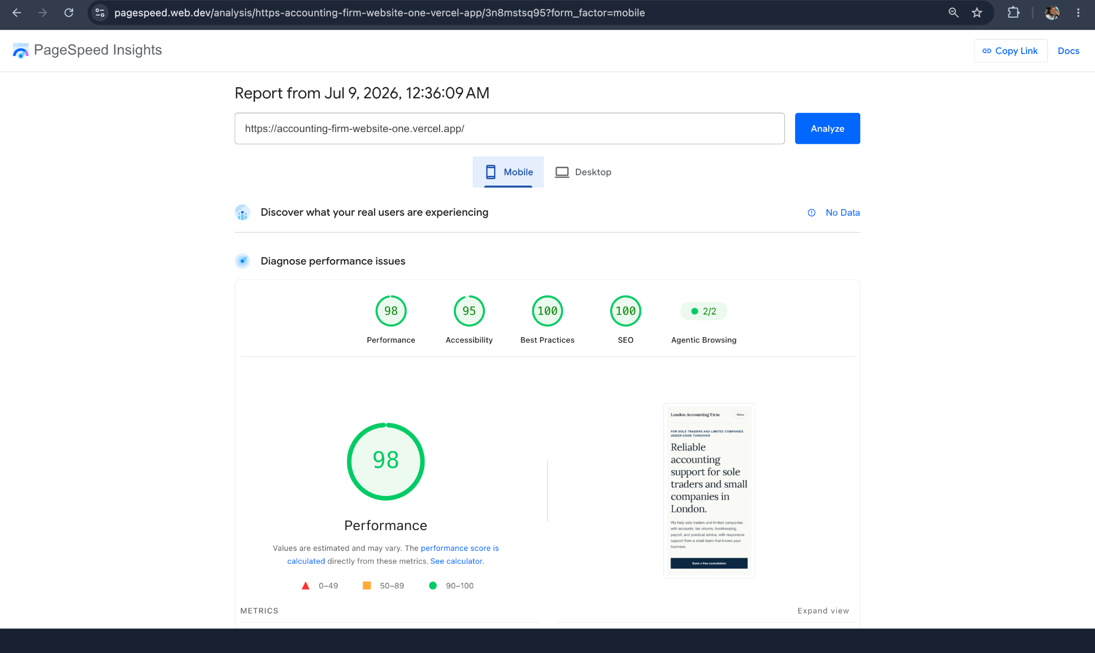
pagespeed-mobile-final.png

Desktop PageSpeed Insights result
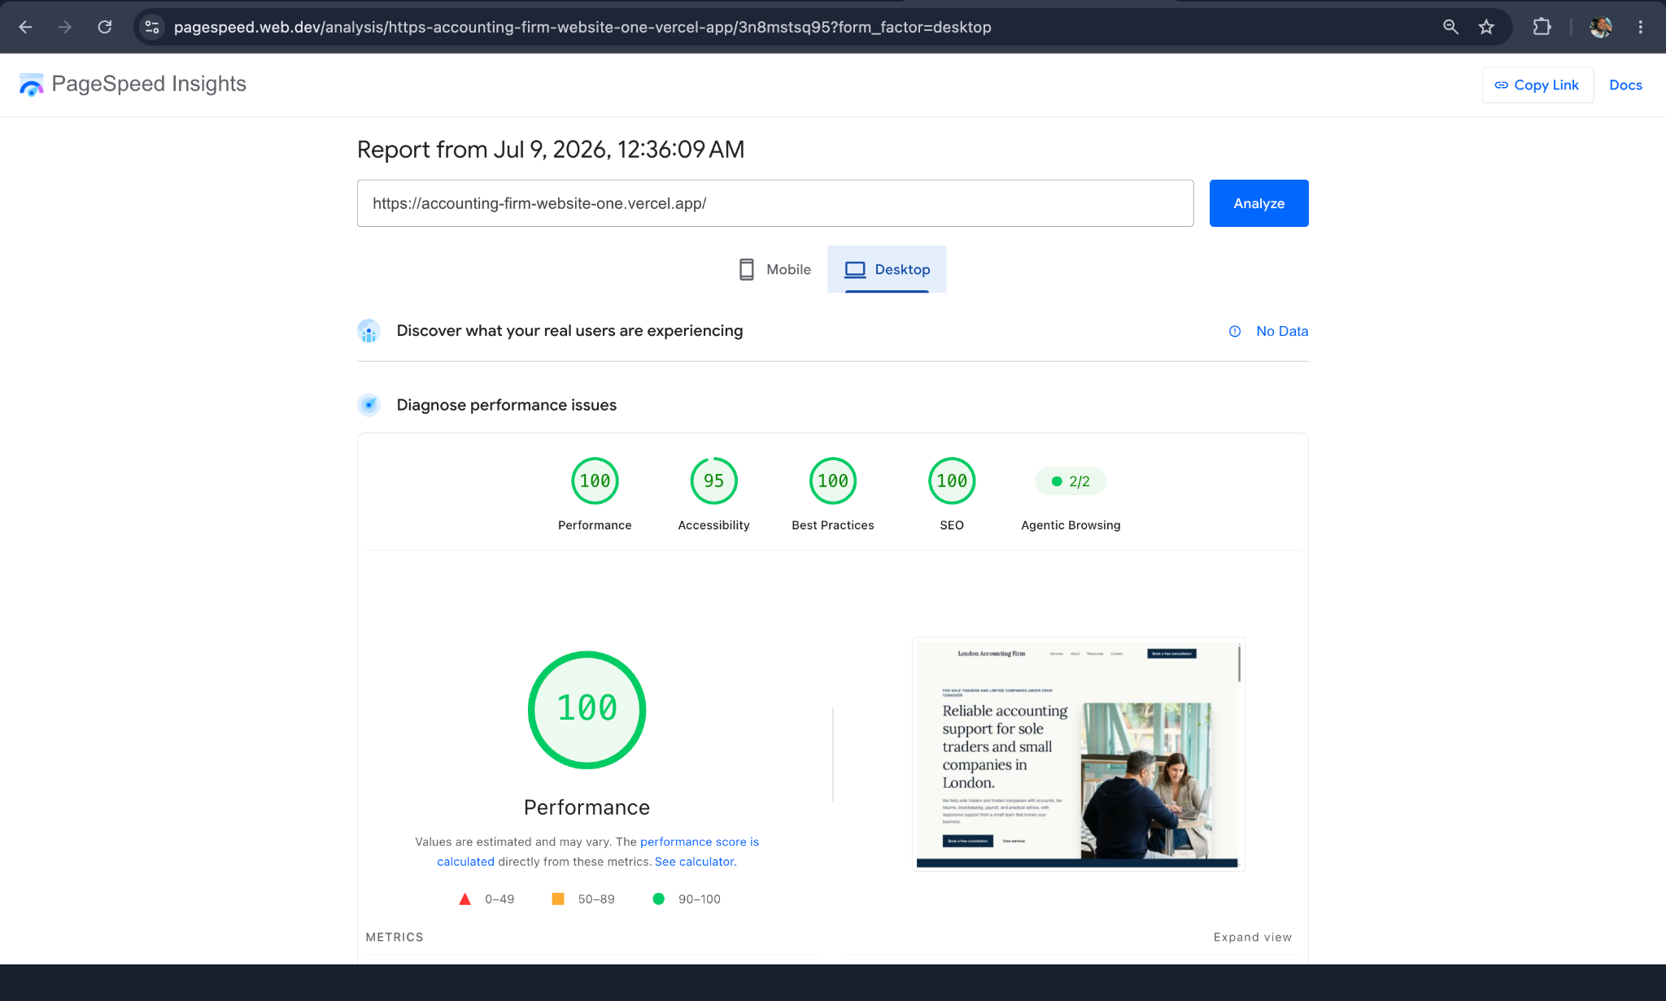
pagespeed-desktop-final.png

